7.Create a simple cloud software application for Students Attendance System using any Cloud Service Provider to demonstrate SaaS include the necessary fields such as name of the students, course, present , Absent, course attendance, OD request, grade, attendance percentage, etc

Step 1: Create the form of student details

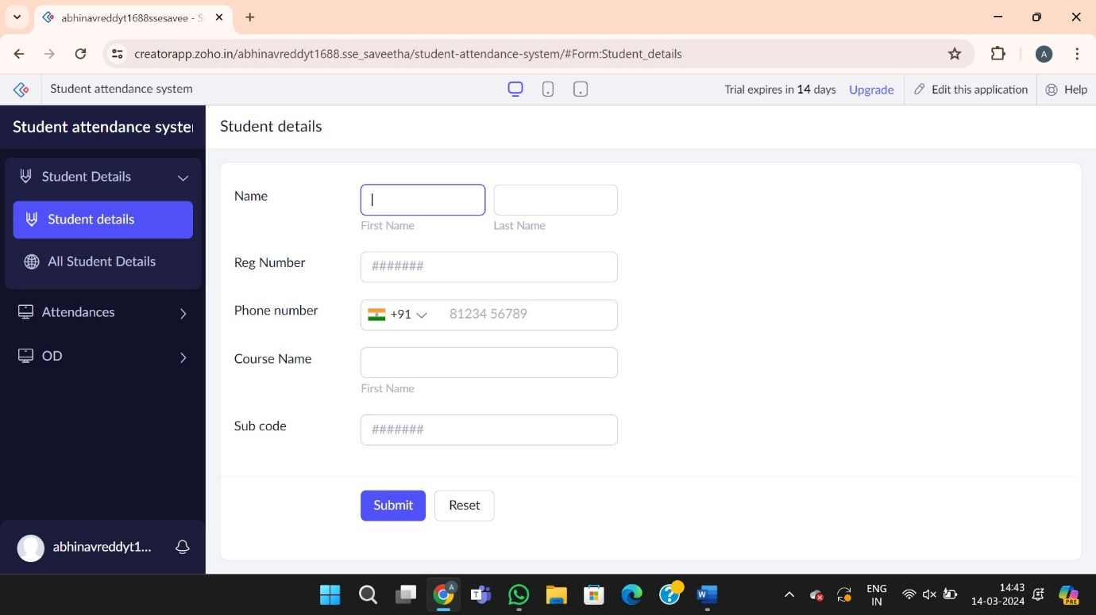

Step 2: Create the attendance form for the course details for the od request

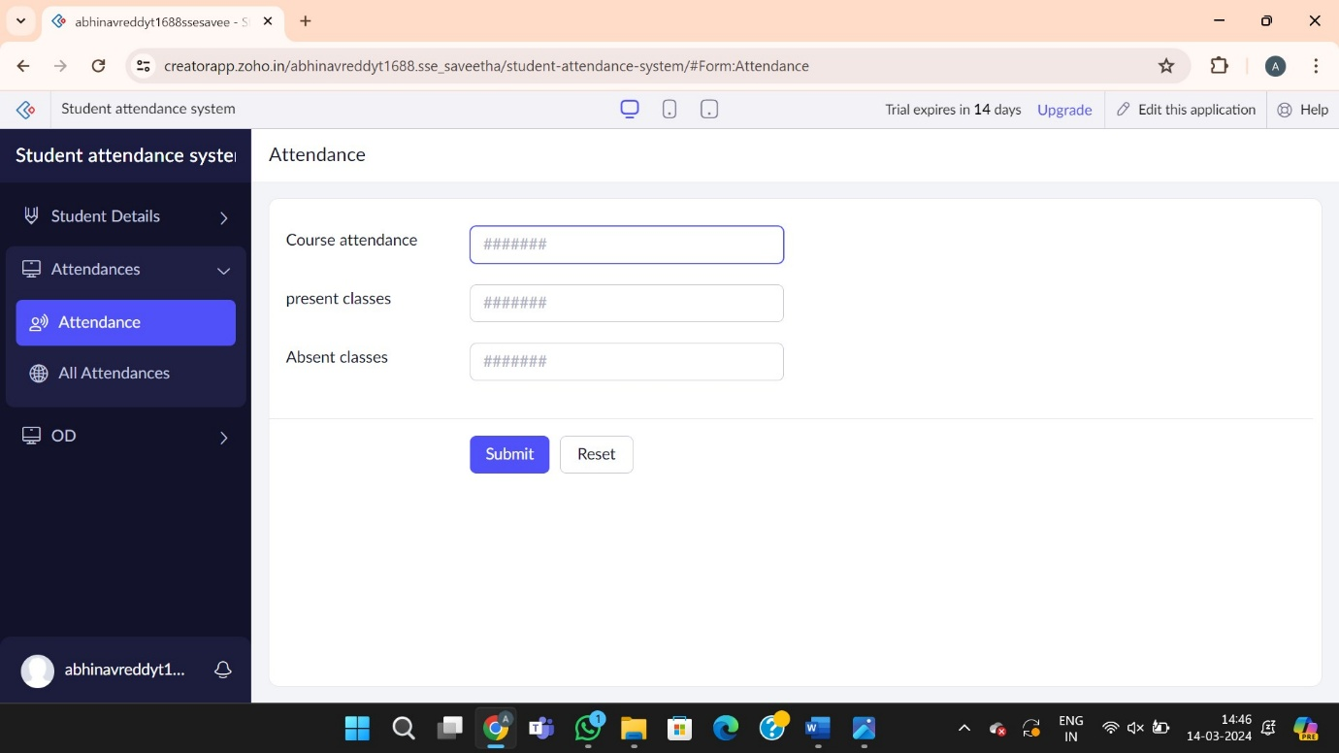

Step 3: Create the form for od request

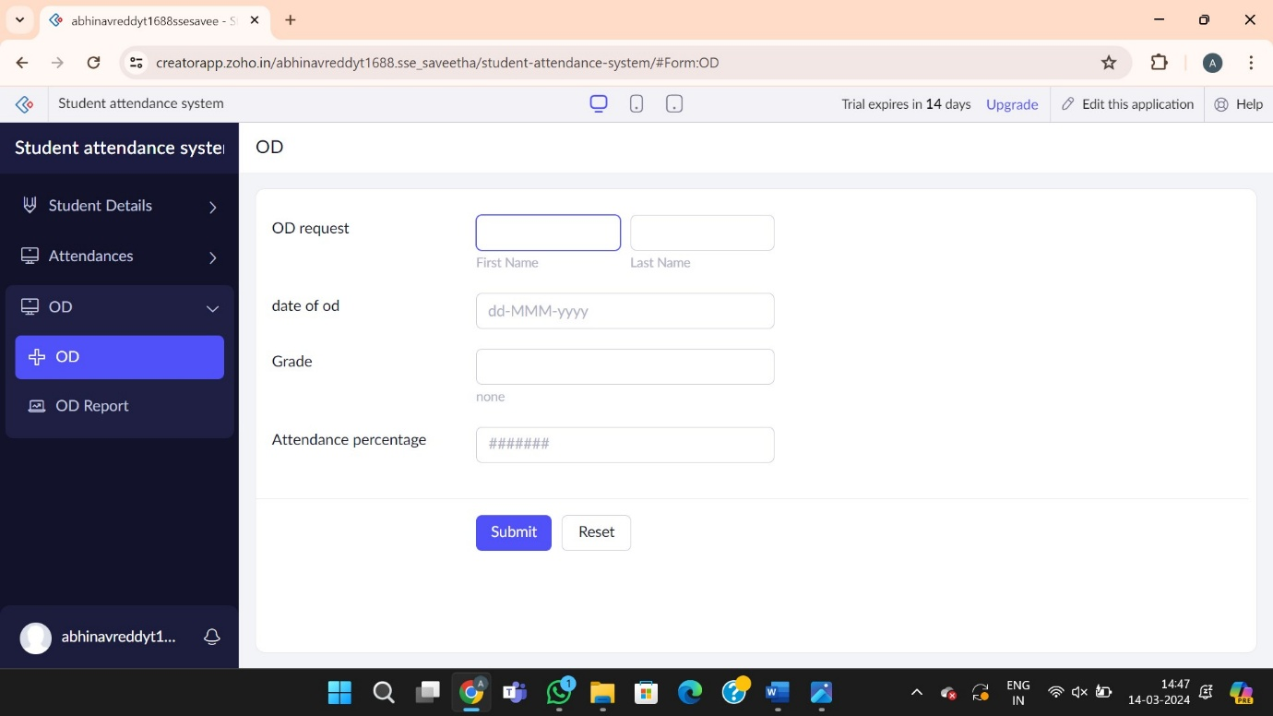

Step 4: Report forms of the od request for student attendance system

